RGB LED Color Mixer
Arduino + I2C LCD + Potentiometer
Project Documentation
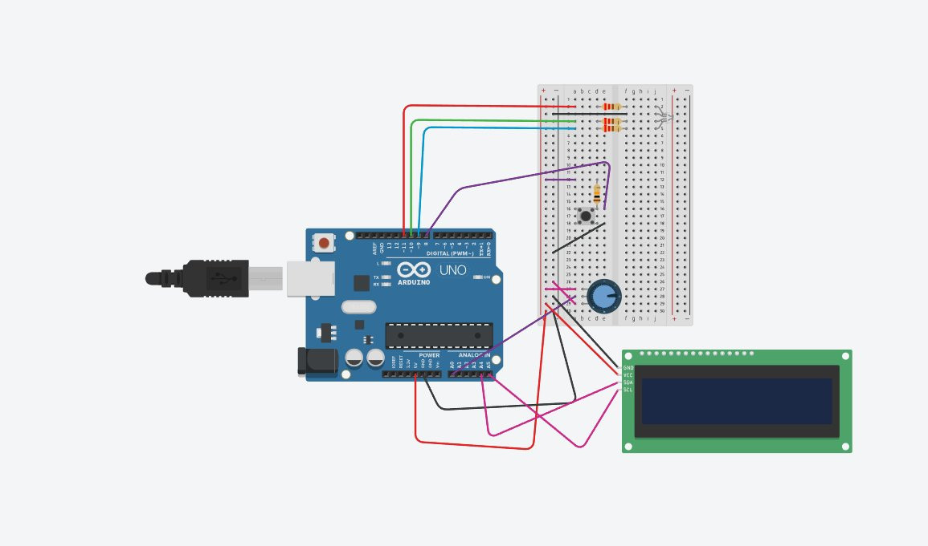

Aditya
Manufacturing Science & Engineering | Second Year
COEP Technological University, Pune
June 2026

1. Objective
Build an interactive Arduino system that lets a user set custom PWM brightness values (0–255) for each channel of an RGB LED — Red, Green, and Blue — using a single potentiometer. A push button advances the system through sequential configuration stages, and a 16×2 I2C LCD provides real-time feedback at every step, from value selection through animation playback and reset.

2. Bill of Materials

Ref | Qty | Component | Details
R1, R2, R3 | 3 | 220 Ω Resistor | Current limiting for RGB LED
D1 | 1 | RGB LED (Common Cathode) | RCGB LED — Red, Green, Blue channels
U1 | 1 | Arduino Uno R3 | Microcontroller — PWM pins D9, D10, D11
RPOT1 | 1 | 250 kΩ Potentiometer | Analog input on A0 for PWM value setting
S1 | 1 | Push Button | Stage advance — D8 with INPUT_PULLUP
R4 | 1 | 10 kΩ Resistor | Button pull-down resistor
U2 | 1 | 16×2 I2C LCD | PCF8574-based, I2C address 0x27

3. Circuit Schematic
The schematic below was exported from Tinkercad Circuits. It shows all component connections including the I2C LCD (SDA→A4, SCL→A5), the common-cathode RGB LED with 220Ω current-limiting resistors on PWM pins D9–D11, the potentiometer on A0, and the push button on D8 with INPUT_PULLUP enabled in firmware.

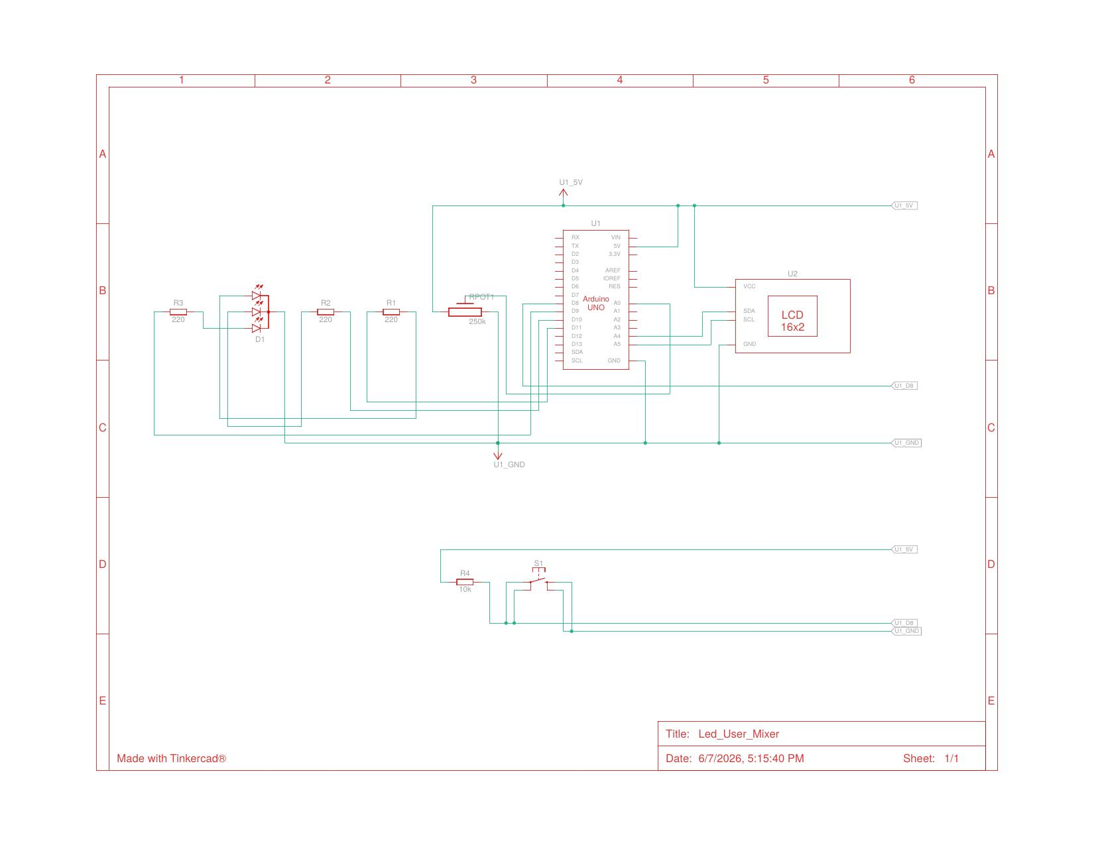
Fig 1. Tinkercad schematic — Led_User_Mixer

Pin Connection Summary
Component | Arduino Pin | Notes
Red LED (via R1 220Ω) | D11 (PWM) | analogWrite 0–255
Green LED (via R2 220Ω) | D10 (PWM) | analogWrite 0–255
Blue LED (via R3 220Ω) | D9 (PWM) | analogWrite 0–255
Push Button | D8 | INPUT_PULLUP; active LOW
Potentiometer (wiper) | A0 | 0–1023 → mapped to 0–255
LCD SDA | A4 | I2C data line
LCD SCL | A5 | I2C clock line

4. How It Works — Stage by Stage
The program is a button-driven state machine. A counter variable tracks the current stage. Each button press increments the counter, advancing to the next configuration step. A messagePrinted boolean flag prevents one-shot stages (summary, animation, reset) from executing repeatedly inside loop().

Stage 0 — Startup / Reset
On power-up (or after a full cycle), the LCD displays "Button To Start". No LED output is active. The system waits idle for the first button press.
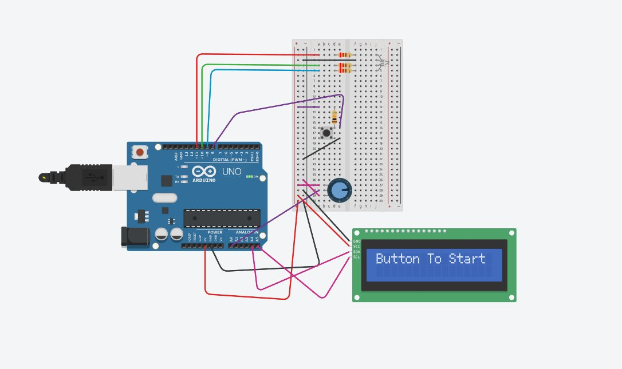
Fig 2. Stage 0 — Startup screen

Stage 1 — Set Red Channel
Turning the potentiometer adjusts the Red PWM value live (0–255). The LCD shows "Red" on line 1 and the current value on line 2. The value is not locked until the button is pressed.
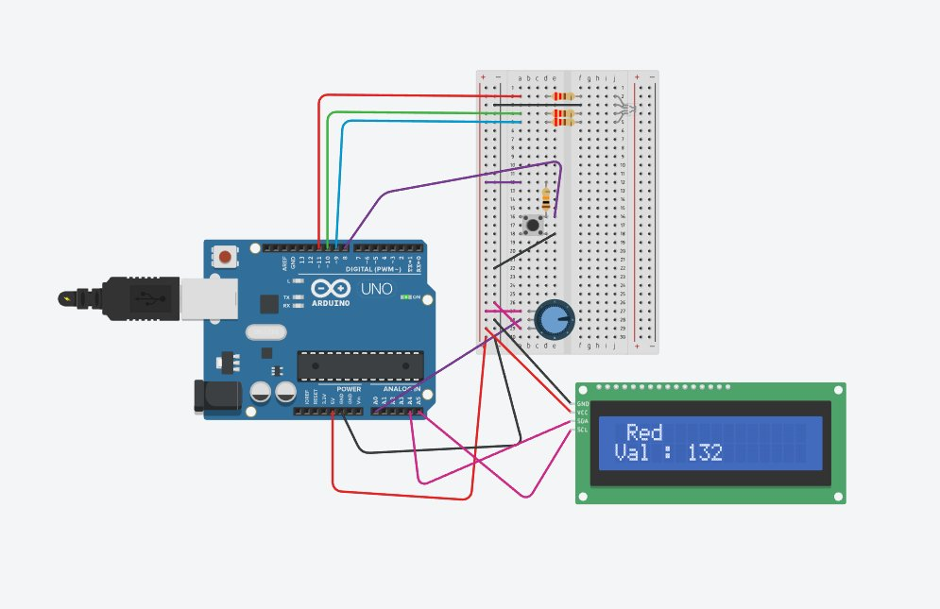
Fig 3. Stage 1 — Setting Red value (shown: 132)

Stage 2 — Set Green Channel
Same flow for the Green channel. LCD updates to show "Green" and its live potentiometer reading.
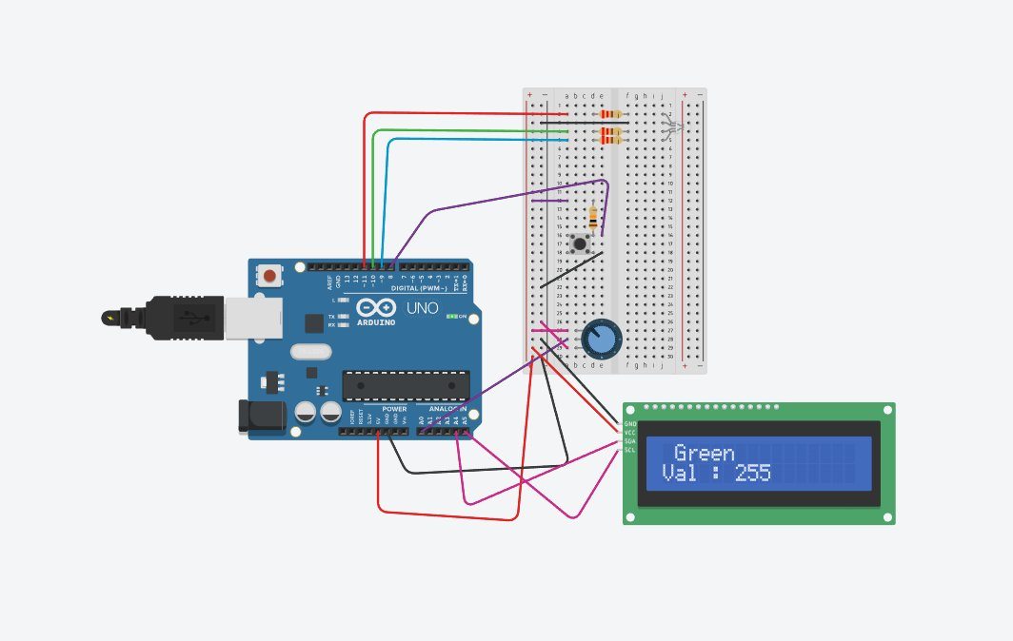
Fig 4. Stage 2 — Setting Green value (shown: 255)

Stage 3 — Set Blue Channel
Same flow for the Blue channel.
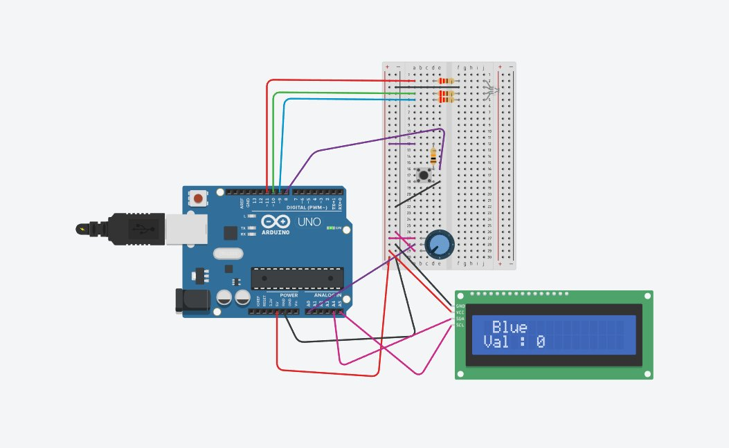
Fig 5. Stage 3 — Setting Blue value (shown: 0)

Stage 4 — Confirm & Summary
All three values are locked. The LCD shows a compact R/G/B summary. Serial Monitor logs each locked value and prompts the user to press once more to begin the animation.
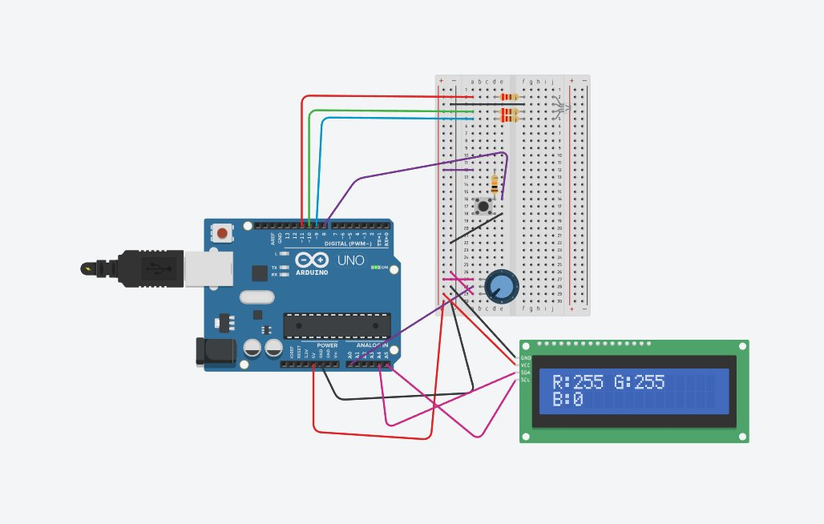
Fig 6. Stage 4 — Summary (R:255 G:255 B:0 → Yellow)

Stage 5 — LED Animation
The LED blinks 6 times at the chosen color (300ms on / 300ms off), then glows continuously for 2.5 seconds. The LCD announces each phase.
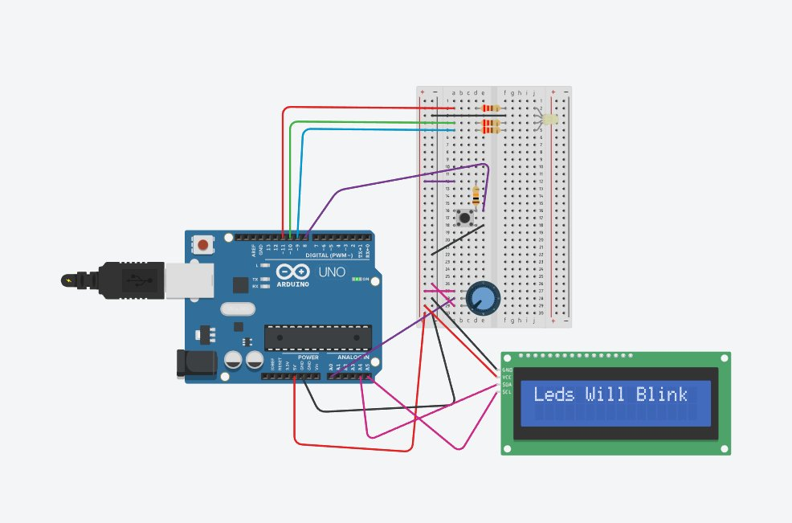
Fig 7. Stage 5 — Blink phase
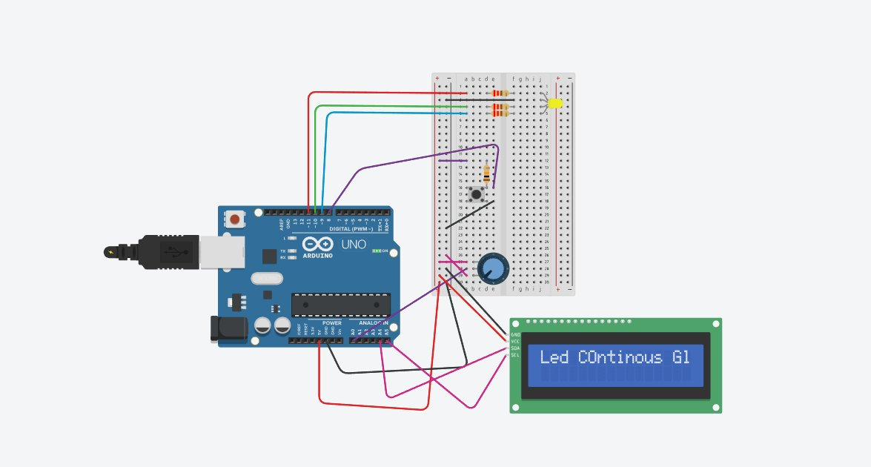
Fig 8. Stage 5 — Continuous glow phase

Stage 6 — Reset
All RGB values reset to 0. The counter resets to 0. The loop restarts from Stage 0, ready for a new color cycle.
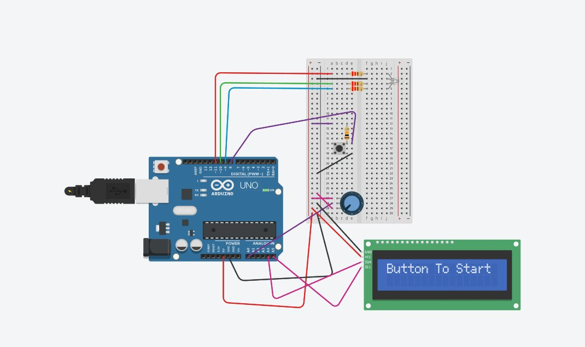
Fig 9. Stage 6 → back to Stage 0

5. Code Architecture

Function | Purpose
Counter() | Reads button pin; detects falling edge (HIGH→LOW); increments counter; 100ms debounce delay
AnalogToDigital() | Reads A0 (0–1023) and returns map() result scaled to 0–255
Lcd_Update(val) | Writes current color name (from array) and live value to LCD; uses targeted cursor overwrite to avoid ghost characters
onLED() | Calls analogWrite() on D9/D10/D11 with stored Red_Val, Green_Val, Blue_Val
offLED() | Writes 0 to all three PWM pins, turning the LED off

State Machine Flow
loop()
├── Counter() → detect button press, increment counter
├── counter == 0 → "Button To Start" (once, via messagePrinted)
├── counter == 1 → live potentiometer → Red_Val; LCD update
├── counter == 2 → live potentiometer → Green_Val; LCD update
├── counter == 3 → live potentiometer → Blue_Val; LCD update
├── counter == 4 → display locked R/G/B summary (once)
├── counter == 5 → blink animation + continuous glow (once)
└── counter == 6 → reset all values + counter to 0

6. Difficulties Faced

Button Bounce
Raw digitalRead() triggered multiple counter increments per single physical press. Fixed by comparing current and previous button state — only incrementing on a HIGH→LOW transition — and adding a 100ms debounce delay inside Counter().

Repeated LCD Writes in loop()
Stages that should execute once (summary display, animation, reset) were running every loop iteration, causing flickering and repeated Serial output. Fixed using the messagePrinted boolean flag: each one-shot block sets it to true at exit and only runs when it is false.

LCD Ghost Characters
Overwriting shorter numbers over longer ones (e.g. "255" → "9") left old digits on screen. Fixed by printing three spaces to the value position before printing the new number, effectively clearing the previous content.

Stage 6 Reset Logic
Setting messagePrinted = false alone at Stage 6 was not sufficient. The counter also had to be reset to 0 in the same block so loop() correctly fell into the counter == 0 branch on the next iteration and displayed the welcome screen.

7. What I Learnt

- PWM with analogWrite() — how duty cycle (0–255) maps to average output voltage and controls per-channel LED brightness.
- map() function — cleanly scaling a sensor reading from one range to another without manual arithmetic.
- State machines on Arduino — using a counter variable to sequence multi-step user interactions without blocking delays in the main loop.
- I2C LCD library — lcd.init(), lcd.backlight(), lcd.setCursor() for precise character placement, and targeted overwrites to avoid full lcd.clear() flicker.
- Edge detection for buttons — comparing current vs. last button state to catch only the moment of press, ignoring held state.
- Boolean flags for one-shot logic — messagePrinted ensures setup-style code runs exactly once per stage inside a repeating loop.
- Analog-to-digital concepts — understanding the 10-bit ADC (1024 steps) on Arduino and how to translate it into a useful control range.

8. Libraries Required

#include <Wire.h>
#include <LiquidCrystal_I2C.h>

// Install via Arduino Library Manager:
// "LiquidCrystal I2C" by Frank de Brabander

9. Tools Used
- Arduino IDE — code authoring and serial monitor
- Tinkercad Circuits — browser-based circuit simulation and schematic export
- GitHub — version control and project portfolio

